一， Use VSCode +PlatformIO to compile Marlin2.0

1.Download the Marlin2.0 firmware : <https://github.com/Msq001/Marlin-bugfix-2.0-biqu>

When the download is complete, unzip it for [standby](C:/Users/win7/AppData/Local/youdao/dict/Application/8.3.1.0/resultui/html/index.html#/javascript:;) [application](C:/Users/win7/AppData/Local/youdao/dict/Application/8.3.1.0/resultui/html/index.html#/javascript:;).

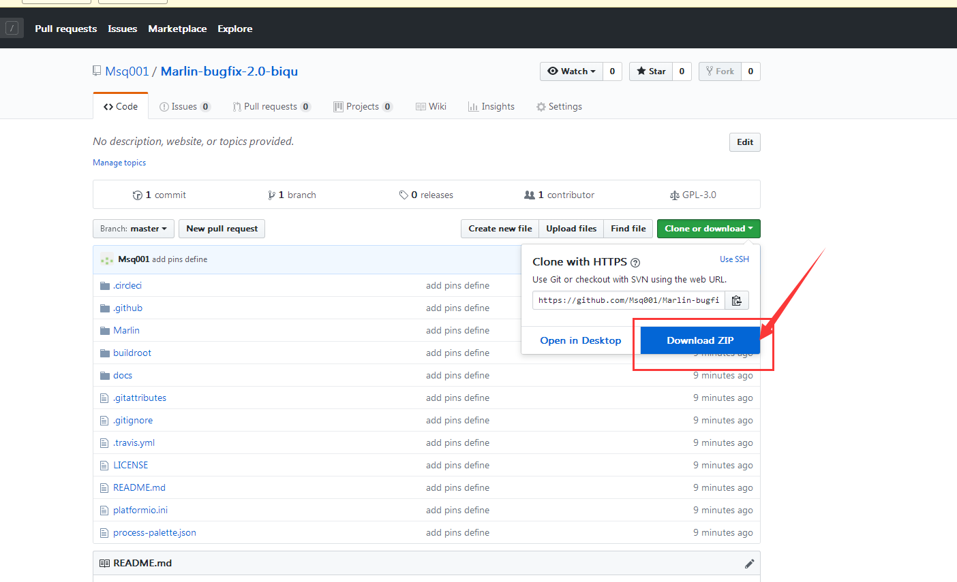

1. Download the Vscode from <https://code.visualstudio.com/Download> .

Note : According to your computer to choose the relate version . Such as the Win7 64 bit operation ,choose the Windows 7,8,10 User Installer 64bit 。

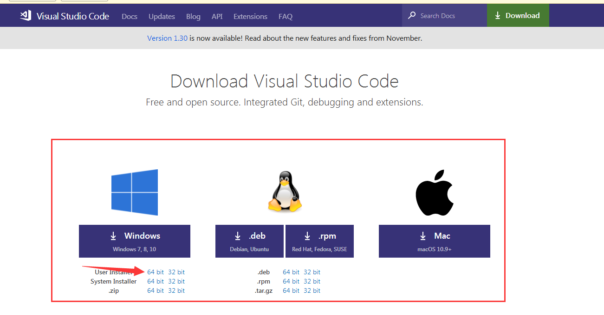

After the download is completed, double-click the installation. After the installation, open VSCode.

3.You also need to install the PlatformIO plugin, click on the steps below . Click on the step 1 in the figure below, enter PlatformIO in step 2 and click step 3 Install to install.

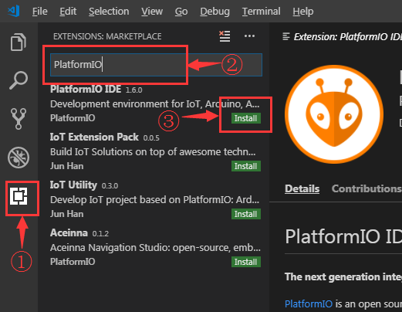

After the download is complete, you need to Reload.

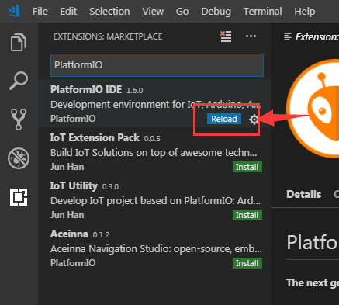

After Reload, you will be prompted to install PlatformIO Core. Please wait.

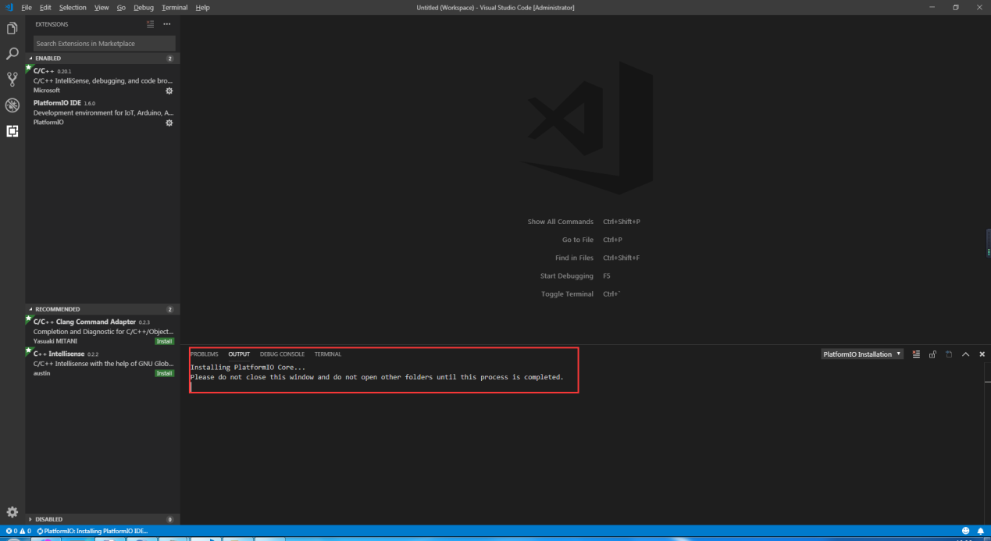

After the installation is successful, you need to Reload it again, and then PlatformIO is installed.

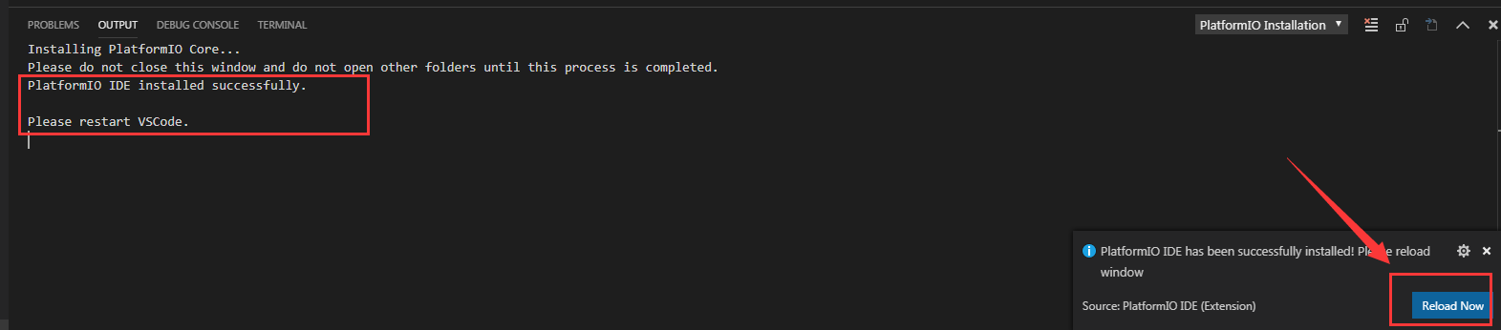

4.In the lower left corner of VSCode, you can see the icon (1), which is PlatformIO plug-in. Click (2) Open Project to Open the Project.

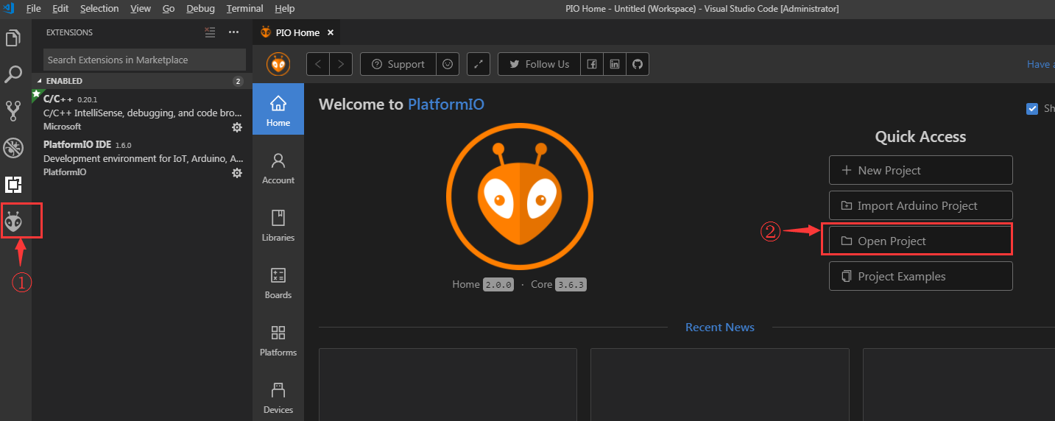

Find the marlin2.0 source directory we extracted In the very first step, and click Open.

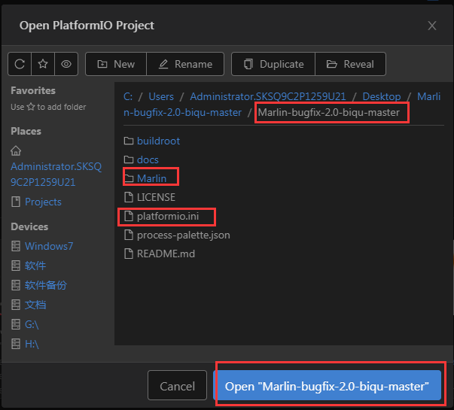

After opening the project, go to the platformio.ini file and change the default environment from megaatmega2560 to LPC1768, env_default = LPC1768

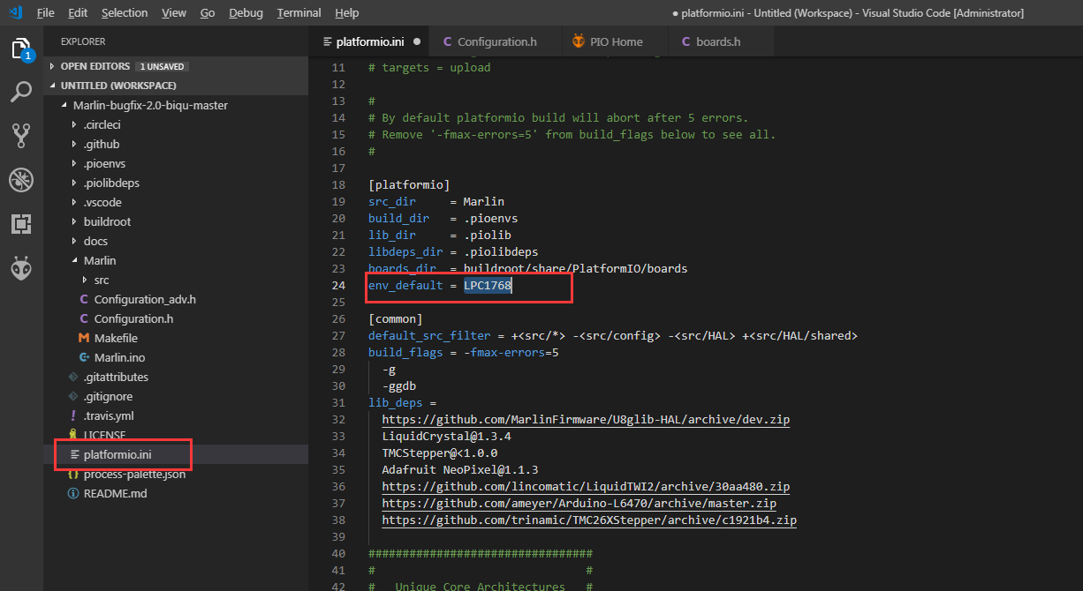

Then go to the configuration.h file and modify it

#define SERIAL_PORT -1

#define SERIAL_PORT_2 0

#define BAUDRATE 115200

#define MOTHERBOARD BOARD_BIQU_SKR_V1_1

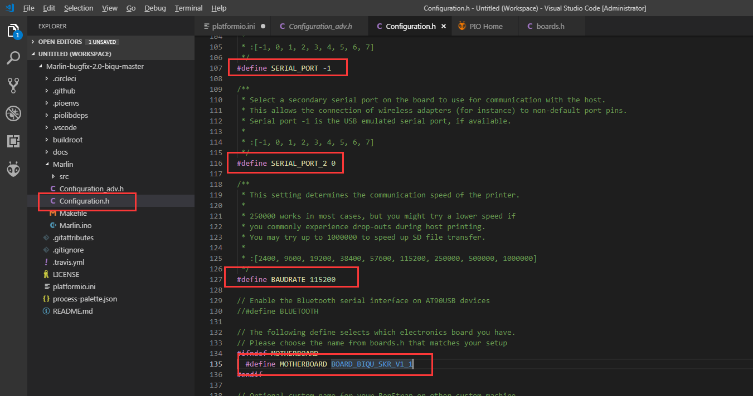

After the modification is completed, press Ctrl+Alt+B, platformio will automatically download the compile component and then compile.

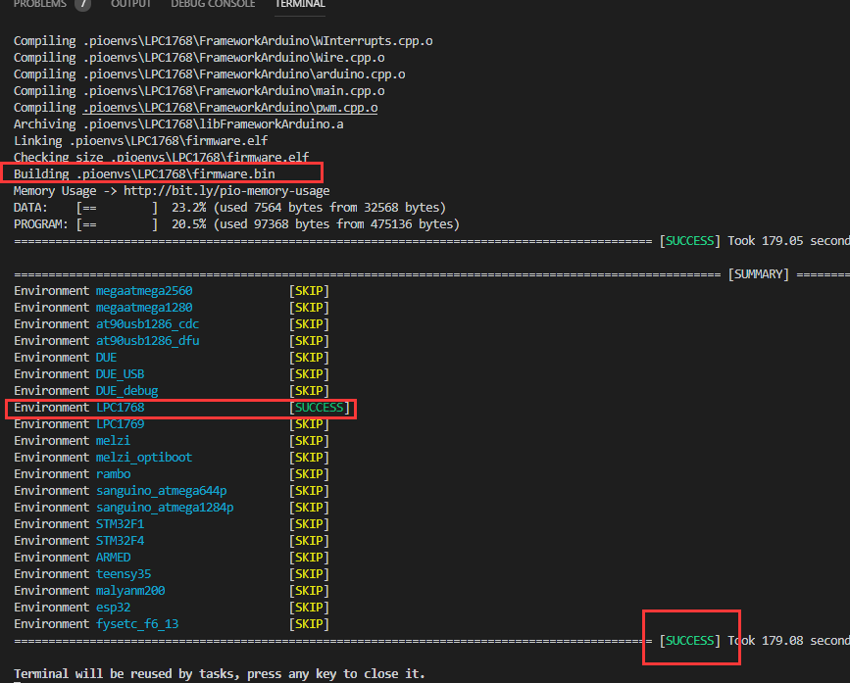

After the compilation is successful, a firmware.bin file will be generated in the .pioenvs\LPC1768 directory. We will copy this file to the TF card of the motherboard, and then reset the motherboard, so that the firmware is burned into the motherboard.

1. Online printing, the first installation of marlin2.0, the computer identification motherboard needs to install usb to serial port driver, in the directory of the firmware as shown below. Because its path is too long, we copy it to an easy to find location, copy it to the desktop.

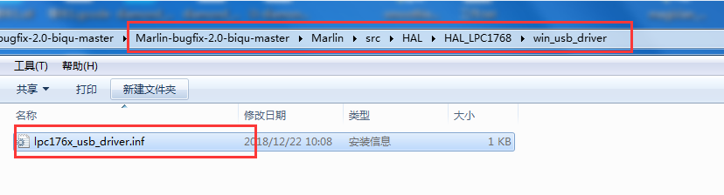

Open the Device manager, you can see that there is an unrecognized Marlin USB Device, click to update the driver software.

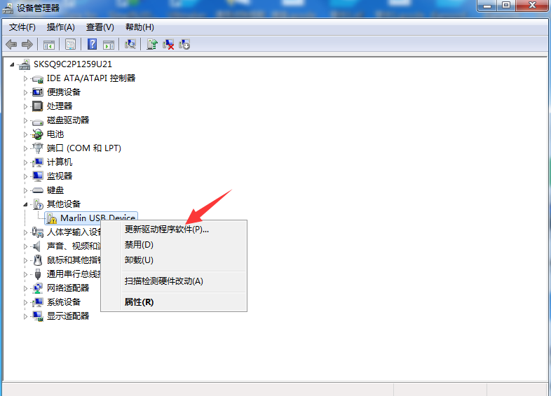

Browse the computer to find the driver software.

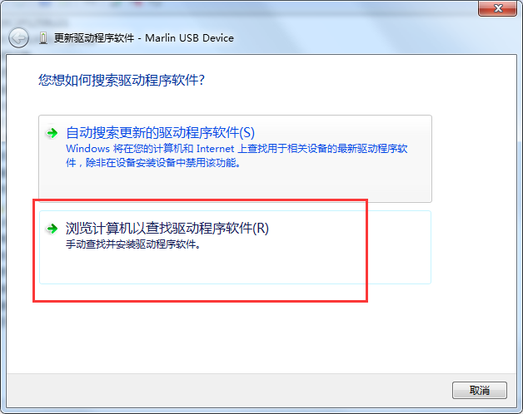

Select the path as the directory where the lpc176x_usb_driver.inf driver is located. We copied it to the desktop before, so select the desktop location : C:\Users\(Users Name)\Desktop and click Next. Check with the below picture .

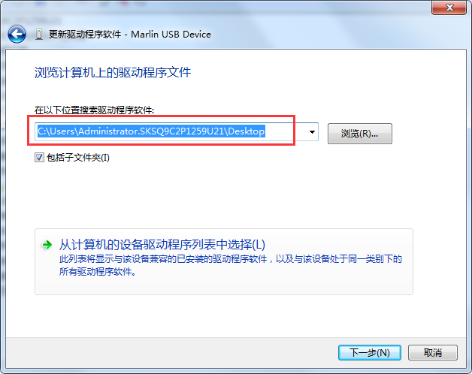

If you have firewall alerts, choose to always install this driver software.

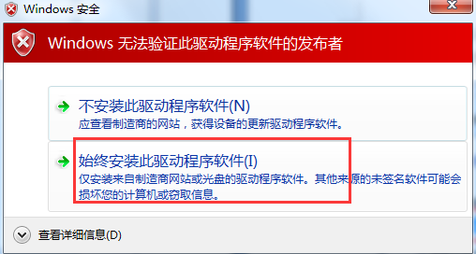

Prompt has been successfully updated driver software, then the driver has been selected successfully, remember the port number, I am COM29.

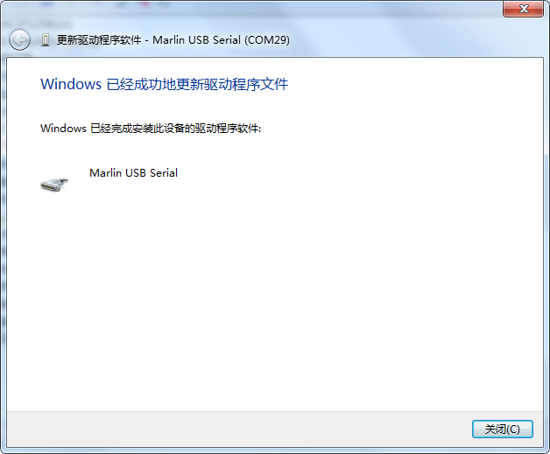

Open the printrun online printing software, take the printrun as an example, select Port COM29, @115200, and then click Connect.

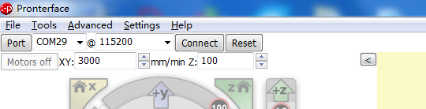

On the right, you can see Printer is now online. This means that you have successfully connected to the Printer. Now you can use your computer to control the Printer

